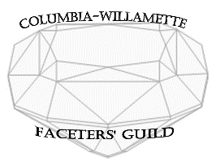
Merle Reinikka Founder’s Award 2022 Information and Entry Form

The Merle Reinikka Founder’s Award intermediate level faceting competition was initiated in 2018 by the Columbia-Willamette Faceters Guild design group and approved by the membership. The challenge is only open to Guild members.

Requirements:
●Facet Material: Synthetic Corundum, any color.
●Size: 8 to 10mm in width.
●Design: Eight of Hearts by Glenn Ruminson. This is in the May issue of FACETS and on our website.
●Only stones which receive a score of 85 or higher are eligible for the award. Of those, the stone with the highest score wins the trophy.
●To enter, just bring your stone to the Guild meeting on or before November 1, 2022 or mail it to the Guild address. Postage both ways is the responsibility of the entrant. Your gem will NOT be insured by CWFG, but care will be taken to ensure its safety. Stone must be received on or before the November 1, 2022 Guild meeting at OMSI (if we are back to OMSI by then).

Stones will be exhibited at the Holiday Dinner, if we have one. Stones will be returned to the owner in January 2023.
Mail to:
Columbia-Willamette Faceters Guild
PO Box 2136
Wilsonville, OR 97070-2136

●Your entry should be in a container that protects it from incidental harm and that is labeled clearly enough so we know who it is from. The judge does not see entrant’s name. Please include this entry form or a facsimile thereof.

Merle Reinikka Founder’s Award Entry 2022

Name:

Postal Address:

Email Address:

Contact Phone:

Description of Gemstone:
(Material, Size, Color, Weight)

